International Institute of Professional Studies

Devi Ahilya Vishwavidyalaya

Indore (M.P.)

A Final Project Report

On

**“ONLINE FOOD ORDERING SYSTEM”**

A Project is submitted in Partial Fulfillment of Requirement of Major Project in VI-Semester

Submitted To:- Submitted By:-

Dr. Rahul Singhai Monika Charpe (IC-2K15-39)

Nishtha Sharma(IC-2K15-43)

Kavisha Tripathi(IC-2K15-34)

**DECLARATION**

We hereby declare that the project entitled “ONLINE FOOD ORDERING SYSTEM” which is submitted by us for the fulfillment of Master of Computer Application (6 years) VIth Semester of International Institute of Professional Studies, and due acknowledgement has been made in text to all other material used.

The matter embodied in this project work is authenticated and is genuinely done by us and has not been submitted to this University or any other university/institute.

We have completed this project work during our VIth Semester session under the supervision of Dr. Rahul Singhai, Senior Lecturer, IIPS, DAVV, Indore.

Signature of Students: -

Monika Charpe:-

Nishtha Sharma:-

Kavisha Tripathi:-

Date:-

**CERTIFICATE FROM GUIDE**

It is to certifythat project on**“ONLINE FOOD ORDERING SYSTEM”** submittedby Ms. Monika Charpe (IC-2K15-39), Ms. Nishtha Sharma (IC-2K15-43) and Kavisha Tripathi (IC-2K15-34) to International Institute of Professional Studies, Devi Ahilya Vishwavidhyalaya,Indore, has been completed under my supervision and the work is carried out and presented in manner required for its acceptance in partial fulfillment for the award of degree of “Master of Computer Application (6 years)” VIth Semester.

Project Guide

Signature: -

Name:-Dr. Rahul Singhai

Date: -

**CERTIFICATE**

It is to certifythat we have examined the project on**“ONLINE FOOD ORDERING SYSTEM”** submittedby Ms. Monika Charpe (IC-2K15-39), Ms. Nishtha Sharma (IC-2K15-43) and Kavisha Tripathi (IC-2K1534) to International Institute of Professional Studies, Devi Ahilya Vishwavidhyalaya, Indore, and here by accord our approval of it as a study carried out and presented in manner required for its acceptance in partial fulfillment for the award of degree of “Master of Computer Application (6 years)” VIth Semester.

Internal Examiner External Examiner

Signature: - Signature: -

Name:- Name:-

Date: - Date:-

**ACKNOWLEDGEMENT**

We acknowledge our sincere thanks to those who have contributed significantly to this project. It is a pleasure to extend deep gratitude to our internal guide Dr. Rahul Singhai, IIPS, DAVV, for his valuable guidance and support and to continuously prompt me for the progress of the project. We thank him for his valuable suggestion towards my project, which helped me in making this project more efficient and user friendly.

We thank and acknowledge each and every ones efforts that helped us in some or the other way small and significant things.

**Table of contents: -**

**S.No. Title Page No.**

Declaration………………………………………………………………….……...2

Certificate from Guide…………………………………………………...................3

Certificate………………………………………………………………..................4

Acknowledgement………………………………………………………………….5

1. Abstract……………………………………………………………………...9
2. Introduction………………………………………………………………...10
   1. Objective of Project………………………………………….................11
   2. Aim of Project……………………………………………….................12
   3. Scope of Project………………………………………………………..12
3. Requirement Specification………………………………………................13
   1. Hardware Requirement……………………………………………..….13
   2. Software Requirement……………………………………………...….13
4. System Analysis……………………………………………………………14
   1. Existing System………………………………………………………...15
   2. Proposed System…………………………………………….................16
   3. SDLC………………………………………………………………….17
   4. Data Dictionary………………………………………………………...24
   5. ER Diagram…………………………………………………………….25
5. System Design……………………………………………………………...27
   1. Modules of Project……………………………………………………..27
   2. User Interface Design…………………………………………………..27
6. Input Data and Validation of Project……………………………………….35
7. Implementation Methodology……………………………………………...36
8. Feature of Project……………………………………………….................37
9. Security Measures………………………………………………………….38
10. Future Scope of Project…………………………………………………….39
11. Limitations of Project………………………………………………………40
12. Conclusion………………………………………………………….............41
13. Bibliography……………………………………………………………….42

**ONLINE FOOD ORDERING SYSTEM**

1. **ABSTRACT**

The online food ordering system provides convenience for the customers. It overcomes the disadvantages of the traditional queuing system. This system increases the takeaway of foods than visitors. Therefore, this system enhances the speed and standardization of taking the order from the customer. It provides a better communication platform the user’s details are noted electronically.

The online food ordering system set up menu online and the customers easily places the order with a simple mouse click. Also with a food menu online you can easily track the orders, maintain customer's database and improve your food delivery service. This system allows the user to select the desired food items from the displayed menu. The user orders the food items. The payment can be made online or pay-on-delivery system. The user’s details are maintained confidential because it maintains a separate account for each user. An id and password is provided for each user. Therefore, it provides a more secured ordering.

1. **INTRODUCTION**

It is known globally that, in today’s market, it is extremely difficult to start a new small-scale business and live-through the competition from the well-established and settled owners. In fast paced time of today, when everyone is squeezed for time, the majority of people are finicky when it comes to placing a food order. The customers of today are not only attracted because placing an order online is very convenient but also because they have visibility into the items offered, price and extremely simplified navigation for the order.

Online ordering system that I am proposing here, greatly simplifies the ordering process for both the customer and the restaurant. System presents an interactive and up-to-date menu with all available options in an easy to use manner. Customer can choose one or more items to place an order which will land in the Cart. Customer can view all the order details in the cart before checking out. At the end, customer gets order confirmation details. Once the order is placed it is entered in the database and retrieved in pretty much real time. This allows Restaurant Employees to quickly go through the orders as they are received and process all orders efficiently and effectively with minimal delays and confusion.

**2.1Aim of Project:**

The aim of the project is to develop a reliability, convenient and accurate Online Food Ordering System.

The Project has the following aim:

* To develop a system that will surely satisfied the customer services.
* To design a system able to accommodate huge amount of orders at a time.
* To evaluate its performance and acceptability in terms of security, user-friendliness, accuracy and reliability.
* To increase the communication between Admin and customer and minimize the time of ordering.

**2.2 Objective of Project:**

The main objective of the project on ONLINE FOOD ORDERING SYSTEM is to manages the details of food, delivery address, order, customer. The project is totally built at administrative end and thus only the administrator is guaranteed the access. The purpose of project is to build an application program to reduce the manual work for managing food, delivery address, order.

**Functionalities of Online Food Ordering System: -**

* Provide the searching facilities based on various factors. Such as food, customer, order.
* Online Food Ordering System also manage the delivery address details online for customer details, order details, food
* It tracks all the information of the items, delivery Address details etc.
* Manage the information of item category
* Shows the information and description of the food, items.
* To increase efficiency of managing the food.
* It deals with the information and transformation of customer
* Manage the information of food
* Manage the information of Customer.

**2.3 Scope of Project:**

It may help collecting perfect management in details. In a very short time, the collection will be obvious, simple and sensible. It will help a person to know the management of passed year perfectly and vividly. It also helps in current all works relative to Online Food Ordering System. It will be also reduced the cost of collecting the management & collection procedure will go on smoothly.

Our project aims at the Business process automation, i.e. we have tried to computerize various processes of Online Food Ordering System.

* In computer system the person has to fill the various forms & number of copies of the forms can be easily generated at a time.
* In computer system, it is not necessary to create the manifest but we can directly print it, which saves our time.
* To assist the staff in capturing the efforts spent on their respective working areas.
* To utilize resources in efficient manner by increasing their productivity through automation
* It satisfies the user requirement
* Be easy to understand by the user and operator
* Be easy to operate
* Have a good user interface
* Delivered on schedule within the budget.

1. **REQUIREMENT SPECIFICATION**

**3.1Hardware Requirements:**

* Hardware - Pentium
* Speed - 1.1 GHz
* RAM - 1GB
* Hard Disk - 20 GB
* Key Board - Standard Windows Keyboard
* Mouse - Two or Three Button Mouse
* Monitor - SVGA

### **3.2Software Requirements:**

* Operating System : Windows
* Database : MySQL
* Web Technologies : Html, JavaScript, CSS
* IDE : Notepad++
* Web Server : Wamp2.2e
* Database JDBC Driver : MySQL JConnector

1. **System Analysis**

System analysis is a process of gathering and interpreting facts, diagnosing problems and the information about the Online Food Ordering System to recommend improvements on the system. it is a problem solving activity that requires intensive communication between the system users and system developers. System analysis or study is an important phase of any system development process. The system is studied to the minutest detail and analyzed. The system analyst plays the role of the interrogator and dwells deep into the working of the present system. The system is viewed as a whole and the input to the system are identified. The outputs from the organizations are traced to the various processes. System analysis is concerned with becoming aware of the problem, identifying the relevant and decisional variables, analyzing and synthesizing the various factors and determining an optimal or at least a satisfactory solution or program of action. A detailed study of the process must be made by various techniques like interviews, questionnaires etc. The data collected by these sources must be scrutinized to arrive to a conclusion. The conclusion is an understanding of how the system functions. This system is called the existing system. Now the existing system is subjected to close study and problem areas are identified. The designer now functions as a problem solver and tries to sort out the difficulties that the enterprise faces. The solutions are given as proposals. The proposal is then weighed with the existing system analytically and the best one is selected. The proposal is presented to the user for an endorsement by the user. The proposal is reviewed on user request and suitable changes are made. This is loop that ends as soon as the user is satisfied with proposal. Preliminary study is the process of gathering and interpreting face, using the information for further studies on the system. Preliminary study is problem solving activity that requires intensive communication between the system users and system developers. It does various feasibility studies. In these studies, a rough figure of the system activities can be obtained, from which the decision about the strategies to be followed for effective system study and analysis can be taken.

**4.1Existing System of Online Food Ordering System:**

In the existing system the exams are done only manually but in proposed system we have to computerize the exams using this application.

* Lack of security of data.
* More man power.
* Time consuming.
* Consumes large volume of pare work.
* Needs manual calculations.
* No direct role for the higher officials.

**4.2Proposed System of Online Food Ordering System:**

The aim of proposed system is to develop a system of improved facilities. The proposed system can overcome all the limitations of the existing system. The system provides proper security and reduces the manual work.

* Security of data.
* Ensure data accuracy ‘s.
* Proper control of the higher officials
* Minimize manual data entry.
* Minimum time needed for the various processing.
* Greater efficiency.
* Better service.
* User friendliness and interactive.
* Minimum time required.

**4.3SYSTEM DEVELOPMENT LIFE CYCLE (SDLC) STAGES:**

1) Problem initiation / Preliminary investigation

2) Requirements /feasibility study

3) Analysis

4) Design

5) Development

6) Testing

7) Implementation

8) Maintenance & support

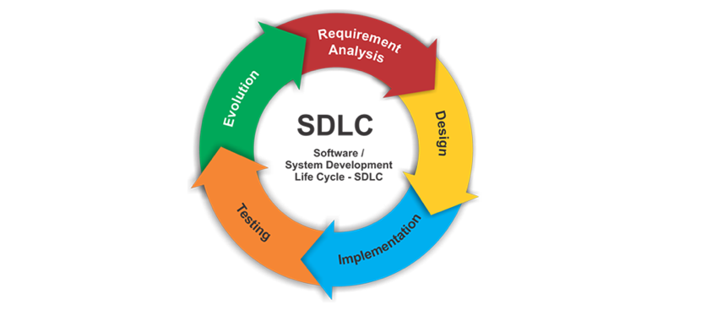

1. **Problem Initiation**

* In this phase of the system development life cycle, the analyst is concerns with identifying Problem, opportunities and objectives.
* The aim is to investigate through an identified need or opportunity and to present a proposal to management may accept.
* The output of this phase is feasibility report containing a problem definition and summary of objectives.
* Rough estimate of the cost involved for the system development is also provided at this stage, because the process of developing a major information system can be costly.

**Identification of Need:**

The old manual system was suffering from a series of drawbacks. Since whole of the system was to be maintained with hands the process of keeping, Maintaining and retrieving the information was very tedious and lengthy. The records were never used to be in a systematic order, there used to be lots of difficulties in associating any particular transaction with a particular context. If any information was to found it was required to go through the different register, documents there would never exist anything like report generation. There would always be unnecessary consumption of time while entering records and retrieving records. One more problem was that it was very difficult to find errors while handling the records.

The reason behind it is that there is lot of information to be maintained and have to be kept in mind while running the business. For this reason, we have provided features present system is partially automated(computerized), actually existing system is quite-laborious as one has to enter same information at three different places.

1. **Requirements / Feasibility study**

* Feasibility study is conducted to investigate the preliminary specification and development plan for the system.
* Include analysis of project requirement in terms of input data and desired output , processing required to transform input into output.
* The feasibility analysis also includes the technical feasibility of project in terms of available software tools, hardware, and skilled software professionals.

**The feasibility of a proposed system is:**

* **Organizational feasibility** –objective of organization’s strategic plan.
* **Economical feasibility**- cost
* **Technical feasibility** -whether reliable hardware and software, capable of solving the problem
* **Operational feasibility** - ability of management, employees, customers, suppliers, to operate, use of system.

**Feasibility Study:**

After doing the project Online Food Ordering System, study and analysis at the existing or required functionalities of the system, the next task is to do the feasibility study for the project. All projects are feasible - given unlimited resources and infinite time

Feasibility study includes consideration of all the possible ways to provide a solution to the given problem. The proposed solution should satisfy all the user requirements and should be flexible enough so that future changes can be easily done based on the future upcoming requirements.

**Economical Feasibility**

This is a very important aspect to be considered while developing a project. We decided the technology based on minimum possible cost factor.

* All hardware and software cost has to be borne by the organization.
* Overall we have estimated that the benefits the organization is going to receive from the proposed system will surely overcome the initial costs and the later on running cost for system.

**Technical Feasibility**

This included the study of function, performance and constraints that may affect the ability to achieve an acceptable system. For this feasibility study, we studied complete functionality to be provided in the System, as described in the system Requirement Specification (SRS), and checked if everything was possible using complete functionality to be provided in the system, different type of frontend and backend plaformst.

**Operational Feasibility**

No doubt the proposed system is fully GUI based that is very user friendly and all inputs to be taken all self-explanatory even to a layman. Besides, a proper training has been conducted to let know the essence of the system to the users so that they feel comfortable with new system. As far our study is concerned the clients are comfortable and happy as the system has cut down their loads and doing.

1. **Analysis**

In this phase, the system analyst analyses the system needs. Special tools and techniques help the analyst in determination of requirements. At this phase detailed studies of objective is done and analyze no. of solution available for solving the problem/achieve the objective.

There are two major activities performed as part of this phase:

Existing system is studied to solve the problem i.e.

* Find out no of possible solutions, the strengths, weaknesses and compared this with the current system must be defined to serve as evaluation of other alternatives.
* Other alternatives are identified and evaluated.

1. **Design**

In this phase the requirement specifications from first phase are studied in this phase and system design is prepared.

System Design helps in specifying hardware and system requirements and also helps in defining overall system architecture or layout.

**Different architectures are use –**

* **Technical architecture -** defines the hardware, software, and telecommunications equipment required to run the system.
* **Modeling -** the activity of drawing a graphical representation of a design
* **Graphical user interface (GUI)** - the interface to an information system.
* **GUI screen design -** the ability to model the information system screens for an entire system.

**Document should be prepared in design phase are:**

* SRDD-system requirement design document
* FSD- functional specification document
* PS- programmed specification
* GAD- gap analysis document

1. **Development**

* Take all of detailed design documents from the design phase and transform them into an actual system.
* The analyst works with programmers to develop any original software that needed.
* Some of the structured techniques for designing and documenting software include structure charts and pseudo code.

1. **Testing**

* We need to discuss what is being tested, when testing must occur, the steps in testing, the properties to test for and the definition of the overall testing effort.
* Verifies that the system works and meets all of the business requirements defined in the analysis phase.
* With inputs from system design, the system is first developed in small programs called units, which are integrated in the next phase.
* Test conditions - the detailed steps the system must perform along with the expected results of each step.

1. **Implementation**

In this phase acquisition of hardware and software site preparations users training and installation of the system.

* **User documentation -** How to use the system.
* **Online training -** runs over the Internet or off a CDROM.
* **Workshop training -** is held in a classroom
* **System Installation:** There are five topics which describe the process of converting from the existing system to the new one.
* **Data Conversion-** is the process of translating the data from the existing data formats and data definitions to those required by the new system.
* **Training-** Training is the process of teaching all users of the system how to use the functions
* **Hardware/Software Installation-** Hardware/software installation is the process of installing the vendor supplied computer configuration and supplemental applications required to support the system being developed.

1. **Maintenance & support**

* Monitor and support the new system to ensure it continues to meet the business goals.
* System maintenance involves the monitoring, evaluating and modifying of system to make desirable or necessary improvement.

**4.4Data Dictionary:**

This is normally represented as the data about data. It is also termed as metadata some times which gives the data about the data stored in the database. it defines each data term encountered during the analysis and design of a new system. Data elements can describe tiles or the processes.

Following are some major symbols used in the data dictionary

* = equivalent to
* + and
* [] either/ or
* () Optional entry

**Following are some rules, which defines the construction of data dictionary entries:**

1. Words should be defined to understand for what they need and not the variable need by which they may be described in the program.

2. Each word must be unique. We cannot have two definition of the same client.

3. Aliases or synonyms are allowed when two or more enters shows the same meaning. For example, a vendor number may also be called as customer number.

4. A self- defining word should not be decomposed. It means that the reduction of any information in to subpart should be done only if it is really required that is it is not easy to understand directly.

Data dictionary includes information such as the number of records in file, the frequency a process will run, security factor like pass word which user must enter to get excess to the information.

**4.5ER Diagram:**

gives

pays

Customer

Handled

by

Feedback

Bill

On table

Workers

home delivery

makes

Order

1. **System Design of Project**

In this phase, a logical system is built which fulfils the given requirements. Design phase of software development deals with transforming the client’s requirements into a logically working system. Normally, design is performed in the following in the following two steps:

**1. Primary Design Phase:**

In this phase, the system is designed at block level. The blocks are created onthe basis of analysis done in the problem identification phase. Different blocksare created for different functions emphasis is put on minimizing the informationflow between blocks. Thus, all activities which require more interaction are kept in one block.

**2. Secondary Design Phase:**

In the secondary phase the detailed design of every block is performed.

**The general tasks involved in the designed process are the following:**

1. Design various blocks for overall system processes.

2. Design smaller, compact and workable modules in each block.

3. Design various database structures.

4. Specify details of programs to achieve desired functionality.

5. Design the form of inputs, and outputs of the system.

6. Perform documentation of the design.

7. System reviews.

**5.1 Modules of Online Food Ordering System:**

* Title page
* Administrator Login Module: Used to manage order serve.
* Item Management Module: Used for managing the information and details of the Item Category.
* Login Module: Used for managing the login details
* Choice Module: Used to select order in on table or for home delivery.
* Token Module: Used to show time limit in preparing order.
* Order and Bill Module: Used for managing the details of Order and show total.
* Delivery Address Module: Used for managing the details of Delivery Address (at the time of home delivery).
* Feedback Module: Used take Customers opinion.

**Module 1. Title Page**

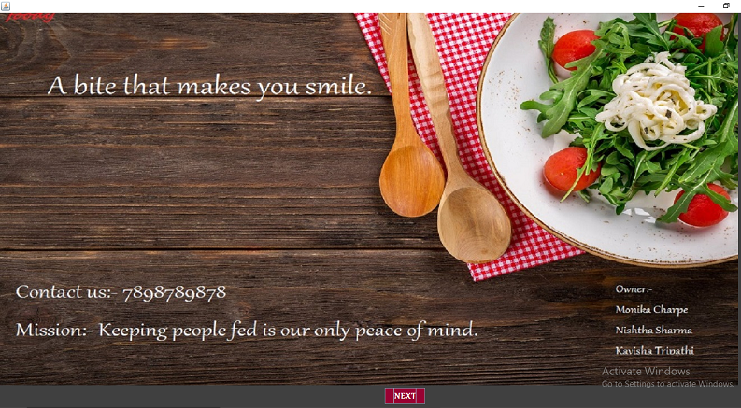

**Module 2. Administrator Login**

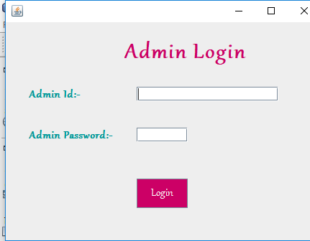

**Module 3. Item Management**

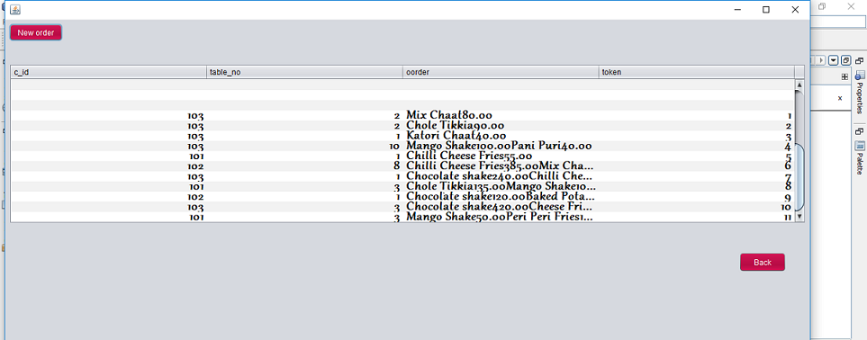

**Module 4. Login**

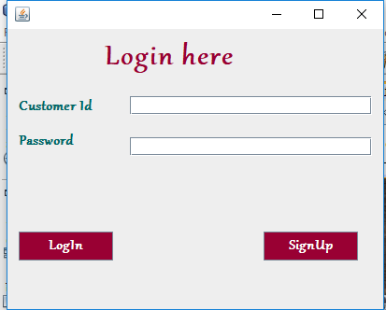

**Module 5. Signup**

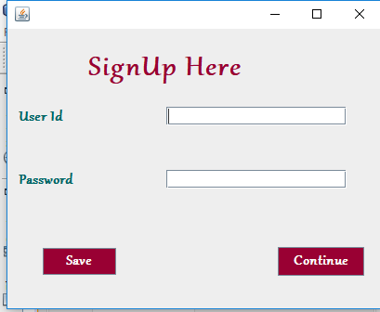

**Module 6. Choice**

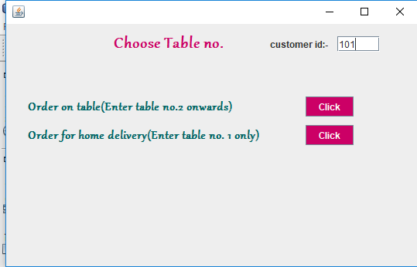

**Module 7. Token**

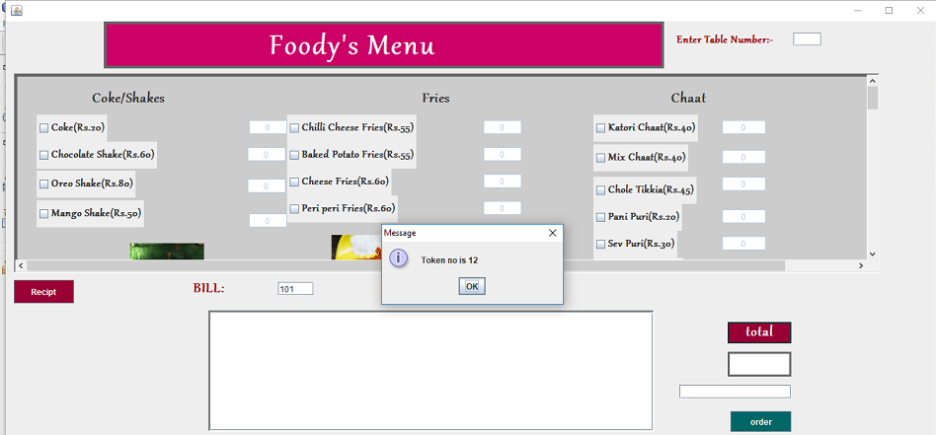

**Module 8. Order and Bill**

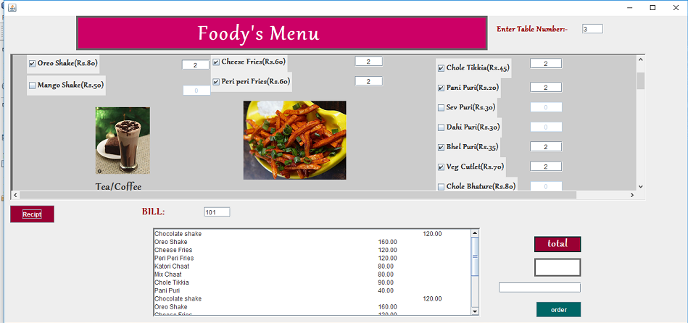

**Module 9. Delivery Address (If order is home delivery)**

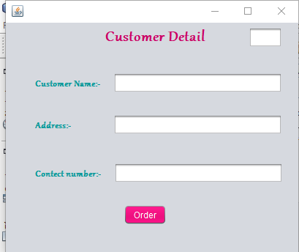

**Module 10. Feedback**

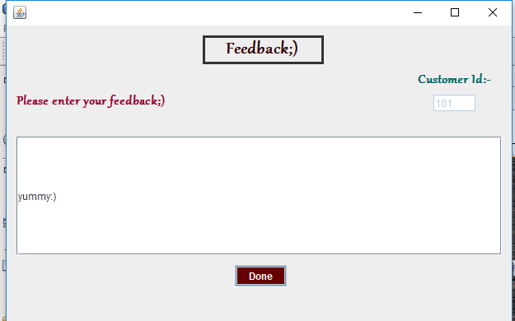

**5.2 User Interface Design**

User Interface Design is concerned with the dialogue between a user and the computer. It is concerned with everything from starting the system or logging into the system to the eventually presentation of desired inputs and outputs. The overall flow of screens and messages is called a dialogue.

**The following steps are various guidelines for User Interface Design:**

* The system user should always be aware of what to do next.
* The screen should be formatted so that various types of information, instructions and messages always appear in the same general display area.
* Message, instructions or information should be displayed long enough to allow the system user to read them.
* Use display attributes sparingly.
* Default values for fields and answers to be entered by the user should be specified.
* A user should not be allowed to proceed without correcting an error.
* The system user should never get an operating system message or fatal error

1. **Input Data and validation of Online Food Ordering System**

* All the fields such as Food, Order are validated and does not take invalid values.
* Each form for Food, Item Category, Delivery Address cannot accept blank value fields
* Avoiding errors in data
* Controlling amount of input
* Integration of all the modules/forms in the system.
* Preparation of the test cases.
* Preparation of the possible test data with all the validation checks.
* Actual testing done manually.
* Recording of all the reproduced errors.
* Modifications done for the errors found during testing.
* Prepared the test result scripts after rectification of the errors.
* Functionality of the entire module/forms.
* Checking of the Coding standards to be maintained during coding.
* Testing the module with all the possible test data.
* Testing of the functionality involving all type of calculations etc.
* Commenting standard in the source files.

1. **Implementation Methodology:**

Model View Controller or MVC as it is popularly called, is a software design pattern for developing web applications. A Model View Controller pattern is made up of the following three parts:

* Model -The lowest level of the pattern which is responsible for maintaining data.
* View -This is responsible for displaying all or a portion of the data to the user.
* Controller -Software Code that controls the interactions between the Model and View.

MVC is popular as it isolates the application logic from the user interface layer and supports separation of concerns. Here the Controller receives all requests for the application and then works with the Model to prepare any data needed by the View. The view then uses the data prepared by the Controller to generate a final presentable response.

1. **Features of Project:**

* Product and Component based
* Creating & Changing Issues at ease
* Query Issue List to any depth
* Reporting & Charting in m
* User Accounts to control the access and maintain security
* Simple Status & Resolutions
* Multi-level Priorities & Severities
* Targets & Milestones for guiding the programmers
* Attachments and additional comments for more information
* Robust database back-ends
* Various level of reports available with a lot of filter criteria's
* It contains better storage capacity.
* accuracy in work.
* Easy & fast retrieval of information
* Easy to update information
* Well-designed reports
* Decrease the load of the person involve in existing manual system.
* Access of any information individually,
* Work becomes very speedy
* Easy to update information

1. **Security Measures:**

Customer id, Password and Address security implemented so that no unauthorized person can login without customer id and password.

* Only signed up customer can order.
* Only Admin can see the order done by customer.

It has two kinds of uses:

1. Administrator
2. Customer

**Administrator:**

He has complete authority of operating the software. The Admin id and Password provided in this project is

Admin id – admin

Password – admin

**Customer:**

When the customer login the system, he can only view menu page. Many customers can login.

Eg. C_id – 101

Password - ayushi

1. **Future Scope of Project:**

In a nutshell, it can be summarized that the future scope of the project circles around maintaining information regarding:

* We can add printer in future.
* We can give more advance software for Online Food Ordering System including more facilities
* We will host the platform on online servers to make it accessible worldwide
* Integrate multiple load balancers to distribute the loads of the system
* Create the master and slave database structure to reduce the overload of the database queries
* Implement the backup mechanism for taking backup of codebase and database on regular basis on different servers

The above mentioned points are the enhancements which can be done to increase the applicability and usage of this project. Here we can maintain the records of Food and Item Category. Also, as it can be seen that now a-days the players are versatile, i.e. so there is a scope for introducing a method to maintain the Online Food Ordering System Enhancements can be done to maintain all the Food, Item Category, Shopping Cart, Customer, Order.

We have left all the options open so that if there is any other future requirement in the system by the user for the enhancement of the system then it is possible to implement them. In the last we would like to thanks all the persons involved in the development of the system directly or indirectly. We hope that the project will serve its purpose for which it is develop there by underlining success of process.

1. **Limitations of Project:**

Although I have put my best efforts to make the software flexible, easy to operate but limitations cannot be ruled out even by me. Though the software presents a broad range of options to its users some intricate options could not be covered into it; partly because of logistic and partly due to lack of sophistication. Paucity of time was also major constraint, thus it was not possible to make the software foolproof and dynamic. Lack of time also compelled me to ignore some part such as storing old result of the candidate etc.

Considerable efforts have made the software easy to operate even for the people not related to the field of computers but it is acknowledged that a layman may find it a bit problematic at the first instance. The user is provided help at each step for his convenience in working with the software.

**List if Limitations which is available in the Online Food Ordering System:**

* Excel export has not been developed for Food, Item Category due to some criticality.
* The transactions are executed in off line mode, hence on line data for Shopping Cart, Customer capture and modification is not possible.
* Offline reports of Food, Order, Shopping Cart cannot be generated due to batch mode execution.

1. **Conclusion of the Project:**

Our project is only a humble venture to satisfy the needs to manage their project work. Several user friendly coding have also adopted. This package shall prove to be a powerful package in satisfying all the requirements of the school. The objective of software planning is to provide a frame work that enables the manger to make reasonable estimates made within a limited time frame at the beginning of the software project and should be updated regularly as the project progresses.

**At the end it is concluded that we have made effort on following points...**

* A description-1 of the background and context of the project and its relation to work already done in the area.
* Made statement of the aims and objectives of the project.
* The description of Purpose, Scope, and applicability.
* We define the problem on which we are working in the project.
* We describe the requirement Specifications of the system and the actions that can be done on these things.
* We understand the problem domain and produce a model of the system, which describes operations that can be performed on the system.
* We included features and operations in detail, including screen layouts.
* We designed user interface and security issues related to system.
* Finally, the system is implemented and tested according to test cases.

1. **Reference and Bibliography:**

* Goggle for problem solving.
* <http://www.tutorialspoint.com/java/>
* <http://www.javatpoint.com/java-tutorial>
* <http://www.tutorialspoint.com/mysql/>
* [www.scribd.com](http://www.scribd.com)
* Reference Book: NetBeans Platform for Beginners